Satya Institute of Technology And Management uses ECAP(Engineering College Automation Package), designed and developed by Web pros Solutions Pvt Ltd, Visakhapatnam. The software hereinafter referred as ECAP, fulfills all the requirements including integrated campuses offering Undergraduate and Post Graduate Courses. ECAP aims at immediate availability of data in required formats ease the work of staff and management and increase in transparency and accountability in administration.

- 1.The following screen shot refers a sample for Student fee status:

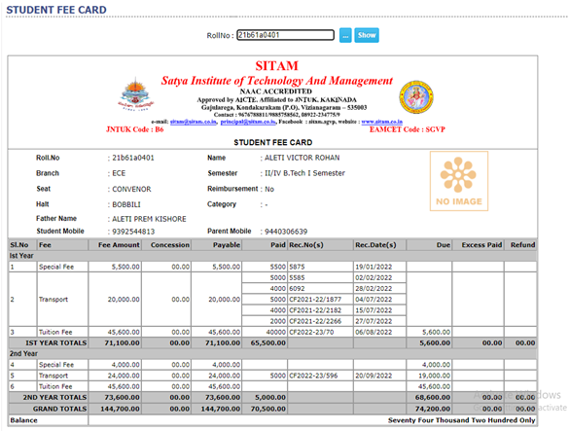

- 2.The following screen shot refers a sample for Student admission register for Regular Candidates:

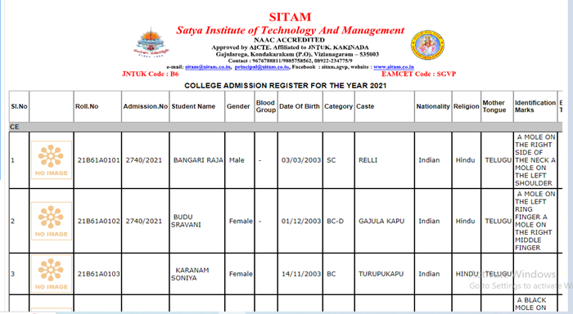

- 3.The following screen shot refers a sample of Student personal details:

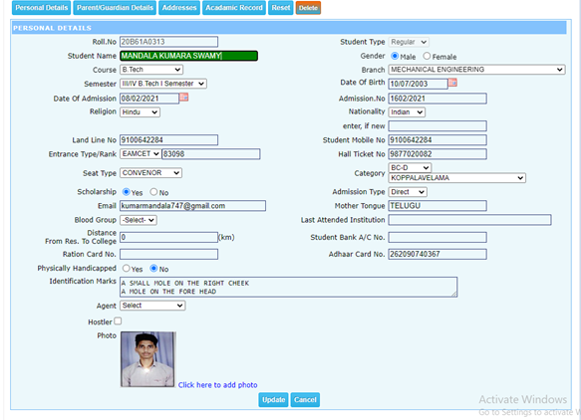

- 4.The following screen shot refers a sample of students certificates check list report:

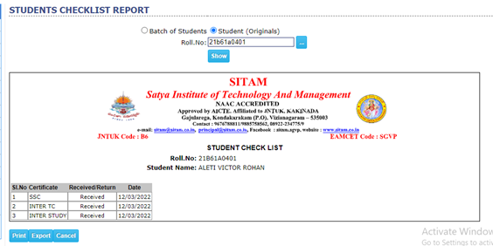

- 5.The following screen shot refers a sample for students transportation data:

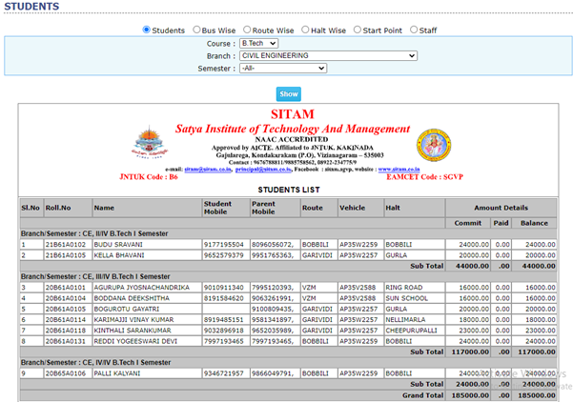

- 6.The following screen shot refers a sample for students Hostel data:

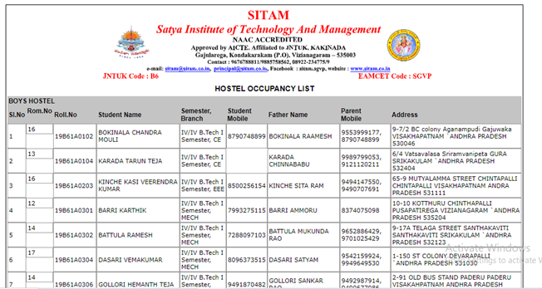

- 7.The following screen shot refers a sample of students detained list:

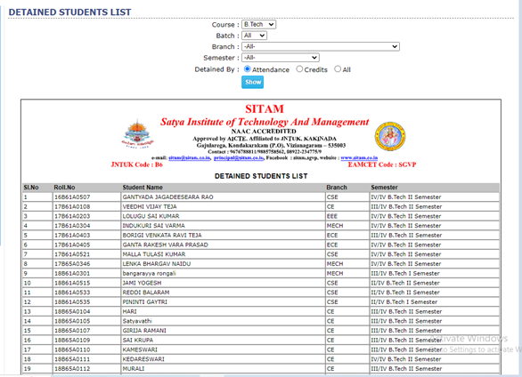

- 8.The following screen shot refers a sample of students performance list:

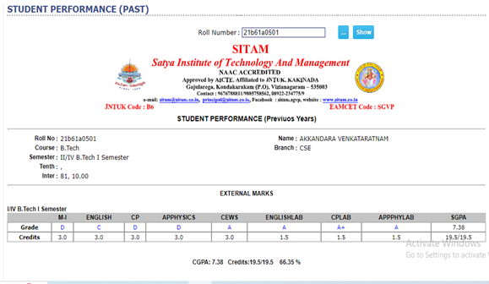
Satya Institute of Technology and Management Vizianagaram also known as SITAM VIZIANAGARAM, is affiliated to JNTU KAKINADA situated in Vizianagaram, Andhra Pradesh. SITAM was established in the year 2008.

  - 1.The Welcome page of JNTUK examinations is as shown below:
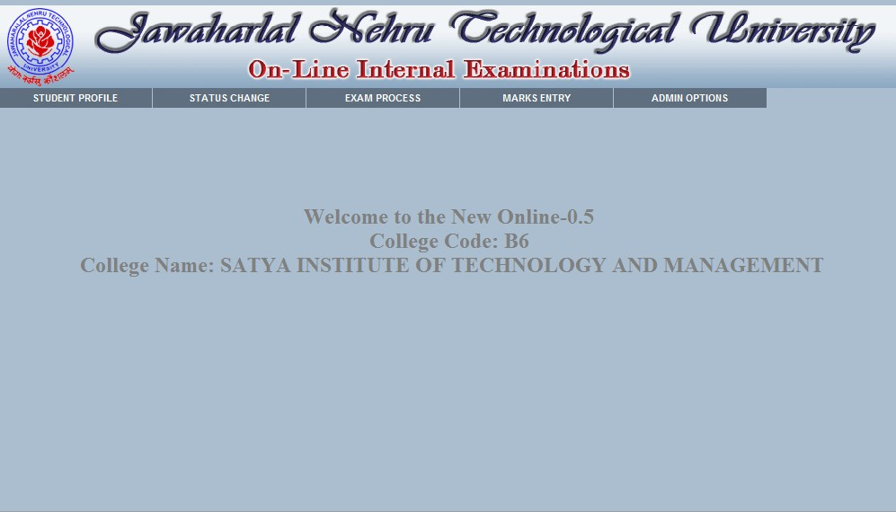

  - 2.The screen shot of student profile page of JNTUK examinations is as shown below:
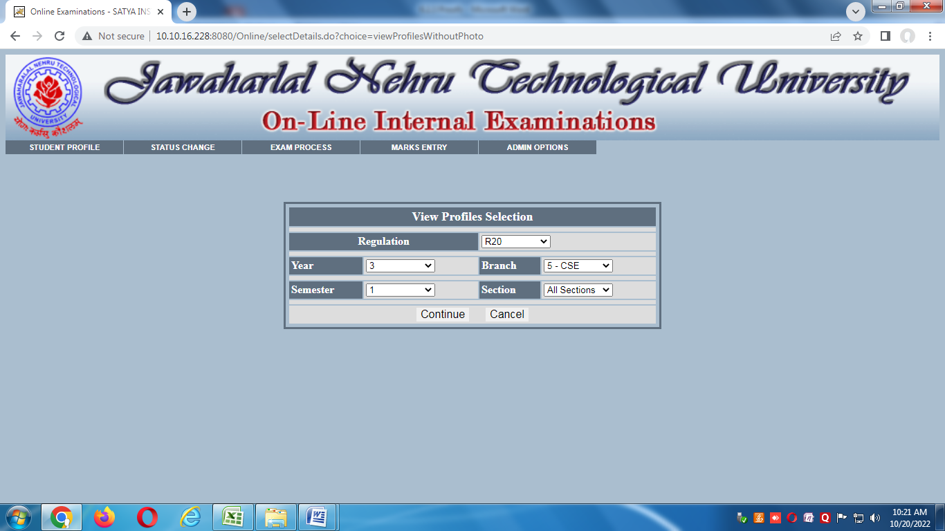

  - 3.The screen shot of list of students under student profile page of JNTUK examinations is as shown below:

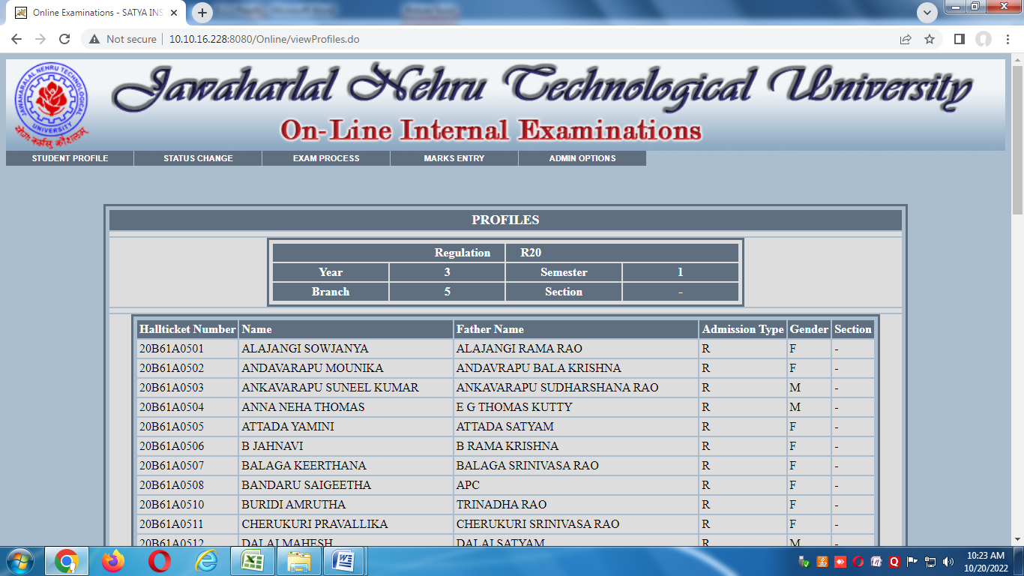

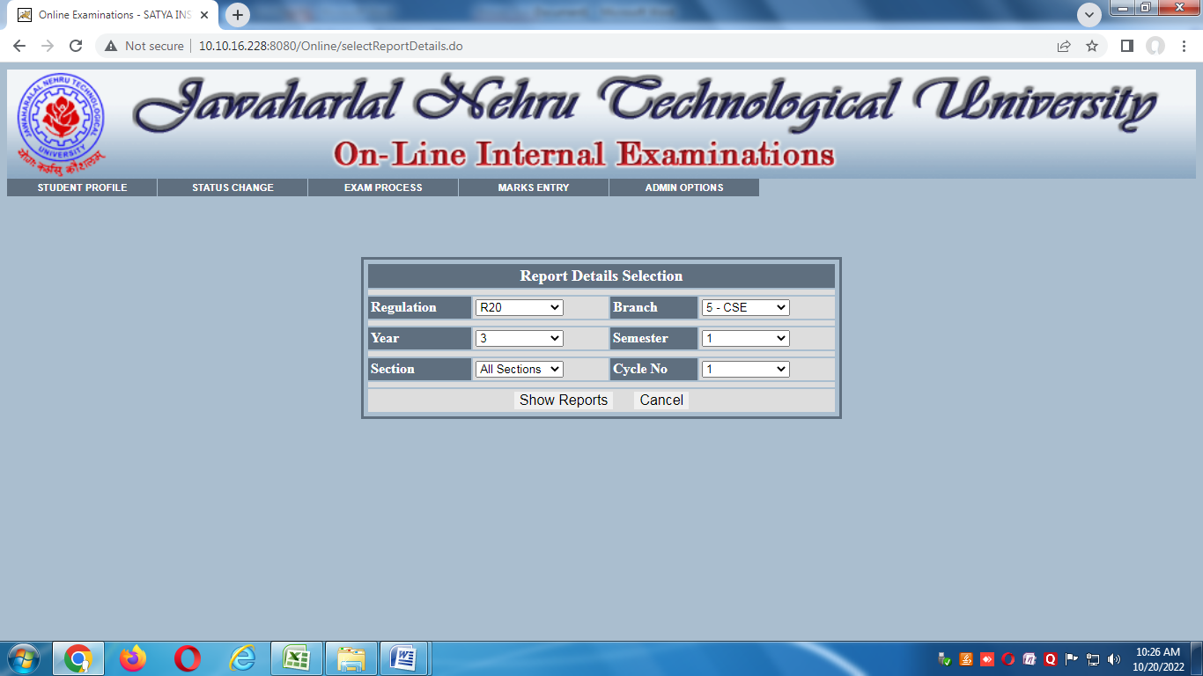
  - 4.The screen shot of students marks report page of JNTUK examinations is as shown below:

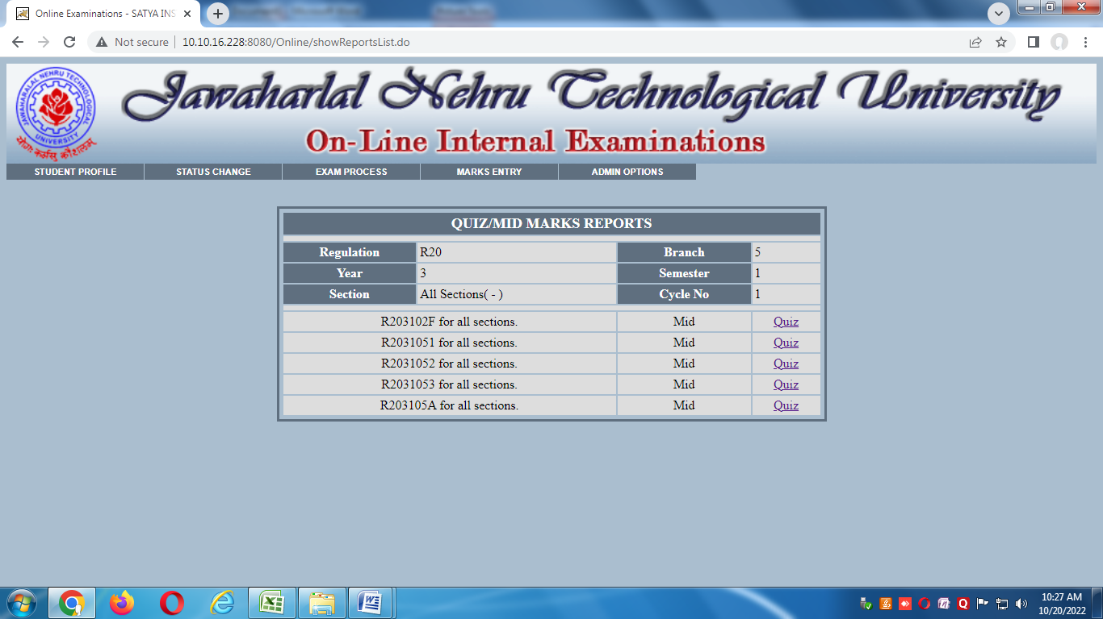

  - 5.The screen shot of sample students quiz marks report page of JNTUK examinations is as shown below:
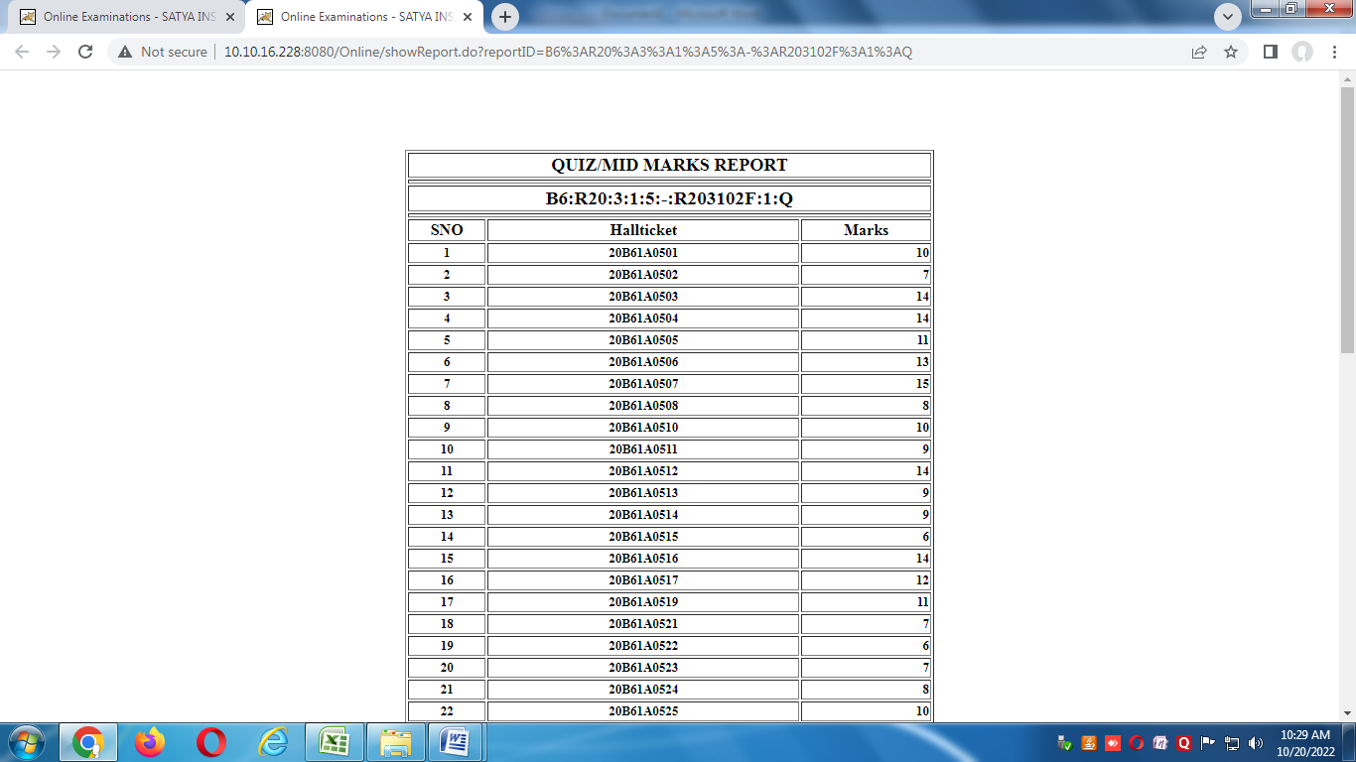

  - 6.The screen shot of sample students mid marks report page of JNTUK examinations is as shown below:
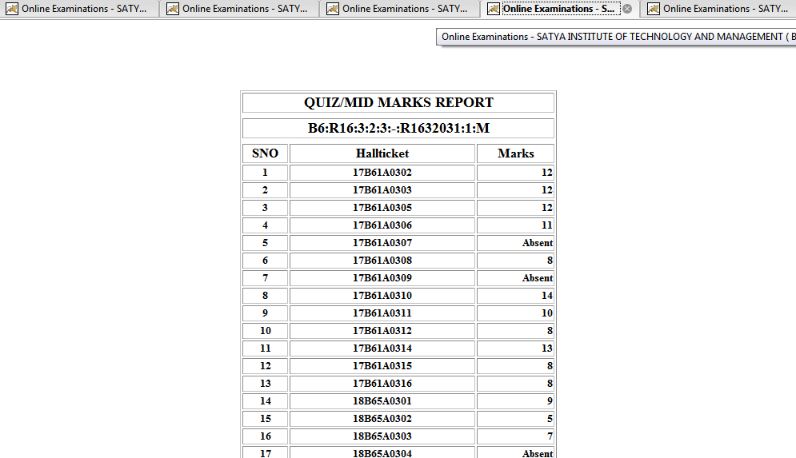

Satya Institute of Technology And Management uses Tally ERP for the maintenance of day- to-day operations along with financial accounting and payroll management. Tally.ERP 9 is one of the most popular accounting software used in India. Tally.ERP 9 delivers integrated payroll software which is completely rewritten to provide all the necessary payroll compliances including Income Tax and Provident Fund.

  - 1.The Welcome page of Tally for SITAM is as shown below:


  - 2.The screen shot of Gateway of Tally is as shown below:
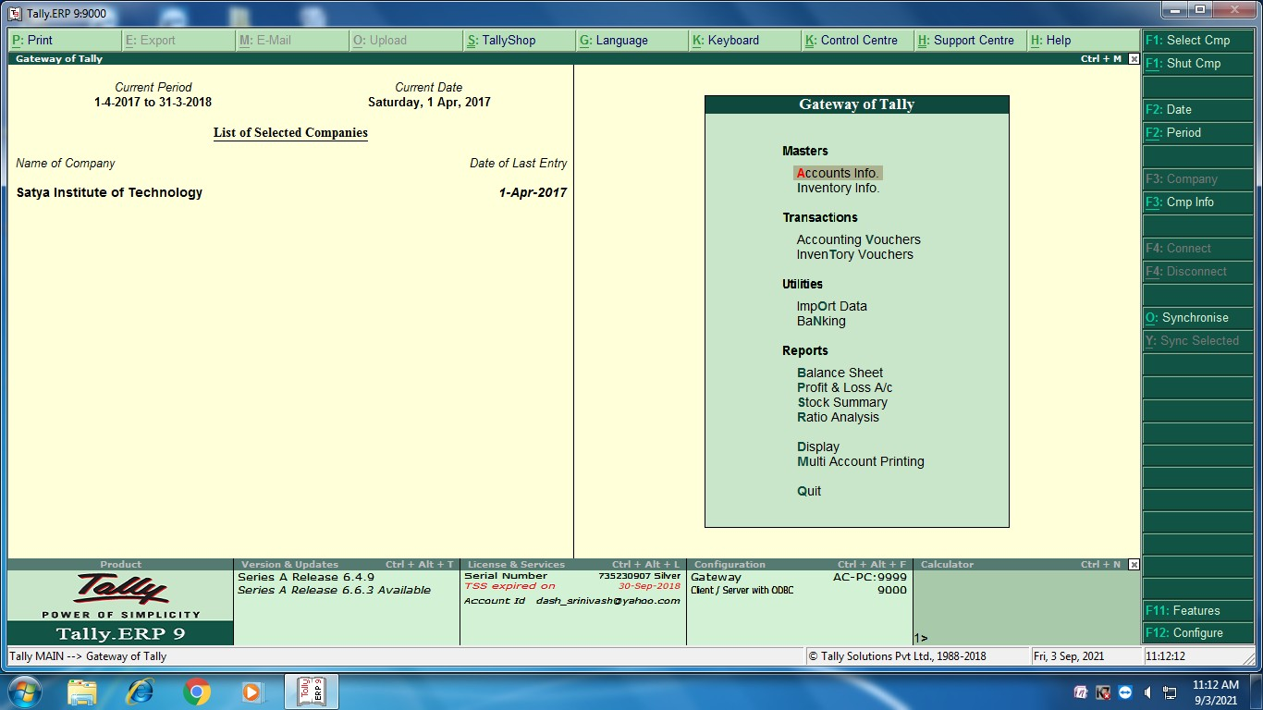

  - 3.The screen shot of balance sheet of SITAM under Sri Botcha Gurunaidu Memorial Educational Society as generated by Tally is shown below:

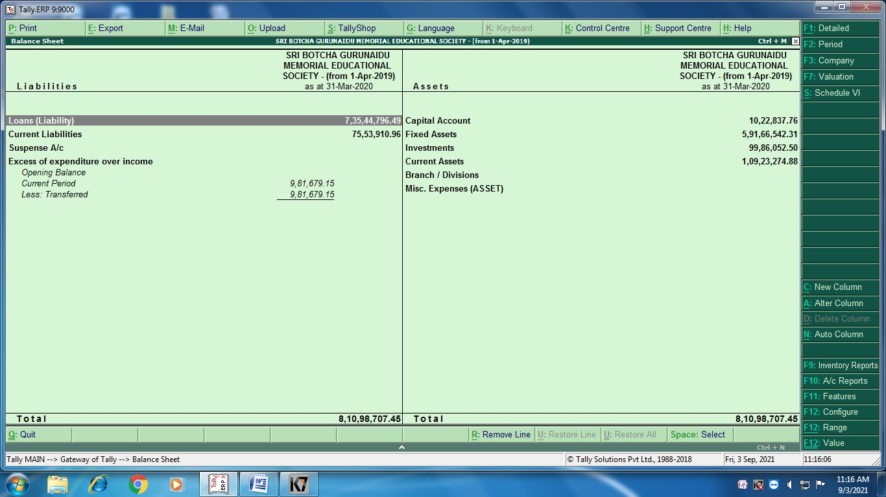

  - 4. The screen shot of particulars of SITAM under Sri Botcha Gurunaidu Memorial Educational Society as generated by Tally is shown below:
